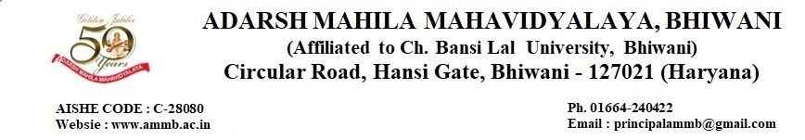
7.1.2 The Institute has facilities and initiative for: (1) Alternate source of energy and energy conservation measures (2) Management of the various types of degradable and non-degradable waste (3) Water Conservation (4) Green Campus Initiative (5) Disabled-friendly, barrier free environment.
7.1.2.1 Alternate source of energy and energy conservation measures
- Energy Audit Report (IQAC) 2020-21
- Energy Audit Report 2021-22
- Energy Audit Report (External Agency) 2021-22
- ISO Certificate for Environment Management System
- ISO Certificate for Quality Management System
- ISO Certificate for Educational Organization Management System
- Survey on Consumption of Electricity in College 2021-22
Link- https://dev.ammb.ac.in/wp-content/uploads/2023/08/7.1.2.1.pdf
7.1.2.2 Management of the various types of degradable and non-degradable waste
- Manure Making Process
- Survey on waste management
- MOU
- Link for vermicomposting and manure making process
- Route plan for waste management
Link- https://dev.ammb.ac.in/wp-content/uploads/2023/08/7.1.2.2.pdf
7.1.2.3 Water Conservation
- Photos of rain water harvesting
- Photos of tank and borewell
- Water distribution layout of college and signage to save water
- Water Audit Report 2020-21 &2021-22
- Certificate of audit report
- Circular
Link- https://dev.ammb.ac.in/wp-content/uploads/2023/08/7.1.2.3.pdf

7.1.2.4 Green Campus Initiative
- Photos and video link of green campus.
- Report of green activity along with NGO- Stand with nature
- MOU
- Green Code of Conduct
- Certificate
- Proof of activities
- Link of green audit/environment audit report
- Link of clean and green campus initiative
Link- https://dev.ammb.ac.in/wp-content/uploads/2023/08/7.1.2.4.pdf

7.1.2.4 Disabled-friendly, barrier free environment.
- Photo of Ramp, divyang enquiry center, signage, divyang friendly washroom
- Policy document for disabled
Link- https://dev.ammb.ac.in/wp-content/uploads/2023/08/7.1.2.5.pdf

