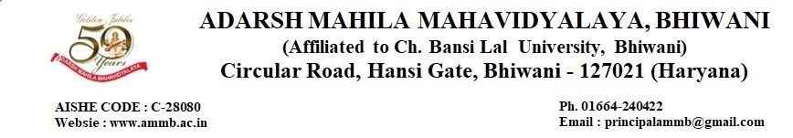

7.2 Best Practice
7.2.1 Creation and awareness of an Eco-friendly campus with the priorities in management of preservation of fauna and flora, management of waste, conservation of green environment, energy and water.
https://dev.ammb.ac.in/wp-content/uploads/2023/08/Main-link-of-7.2.1-.docx

7.2.2 Creation and development of the impressive, outgoing and overall personality of students for attaining self-esteem, positive impact and confidence through mentoring, creating awareness, organizing academic activities along with cultural & sports, deploying them in society as a social server and by providing them ethics.
https://dev.ammb.ac.in/wp-content/uploads/2023/08/Main-link-of-7.2.2-.docx

