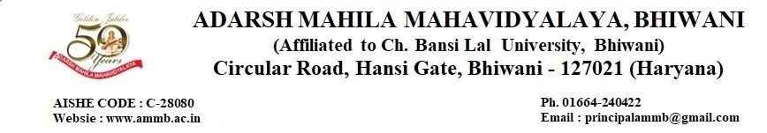
7.1.1 Measures initiated by the Institution for the promotion of Gender equity and Institutional initiatives to celebrate/ organize national and international Commemorative days, event and festivals during the last five years.
7.1.1.1 Safety Measures
        - Security at the gate
        - CCTV cameras in college campus
        - Policy Documents
        - Complaint Registers
        - Minutes of meeting student Grievance & Redressel Cell
        - Photos of Suggestion Boxes
        - Fire Evacuation Plan
        - Automatic Sanitary Napkin Vending Machine
Link- https://dev.ammb.ac.in/wp-content/uploads/2023/07/7.1.1.1.pdf

7.1.1.2 Counseling
        - Gender Equity & Women Empowerment
        - Psychological Guidance & Counseling
        - Hygiene Camps
        - Self Defense , Life Skills ,yoga
        - Mentor mentee System
        - IQAC Meeting
Link- https://dev.ammb.ac.in/wp-content/uploads/2023/07/7.1.1.2.pdf

7.1.1.3 Table of Activities supporting Gender Equity & celebration of commemorative days
        - Table of session 2018-19
        - Table of session 2019-20
        - Table of session 2020-21
        - Table of session 2021-22
        - Table of Session 2022-23
Link- https://dev.ammb.ac.in/wp-content/uploads/2023/07/7.1.1.3.pdf

7.1.1.4 Annual Gender Sensitization Action Plan
        - Session 2020-21
        - Session 2021-22
        - Session 2022-23
Link- https://dev.ammb.ac.in/wp-content/uploads/2023/07/7.1.1.4.pdf

7.1.1.5 Gender Audit Report
        - Session 2020-21
        - Session 2021-22
Link- https://dev.ammb.ac.in/wp-content/uploads/2023/07/7.1.1.5.pdf

